**SMART PUBLIC RESTROOM**

**MENTOR NAME**

**R .PREETHI AP/ECE**

**PRESENTED BY**

**Vidyasagar m**

## ABSTRACT

Public restrooms serve as crucial amenties in various settings, playing a pivotal role in maintaining hygiene and ensuring comfort for individuals.

This paper explores the integration of smart technologies to revolutionize the functionality and user experience within public user experience within public restroom facilities.

The incorporation of sensor-based systems, IoT devices, and AI-driven solutions aims to optimize resource management, hygiene maintenance, and user convenience. Through sensor-equipped faucets, touchless interfaces, occupancy monitoring, and predictive maintenance systems, these smart restrooms endeavor to provide a seamless and hygienic experience.

The paper delves into the technical aspects, benefits, challenges, and potential societal impact of smart public restrooms, envisioning a future where technology transforms these spaces into efficient, comfortable, and sustainable enviroments for all users.

INTRODUCTION

**Public restrooms are integral to our daily lives, and advancements in technology have ushered in a new era of smart public facilities.**

**Smart public restrooms are revolutionizing the way we approach sanitation and convenience, offering a blend of innovative technology, sustainability, and user-centric design.**

**These cutting-edge facilities aim to enhance user experience, optimize resource management, and prioritize hygiene, ultimately redefining the standard for modern public convenience.**

PROPOSAL

BLOCK DIAGRAM

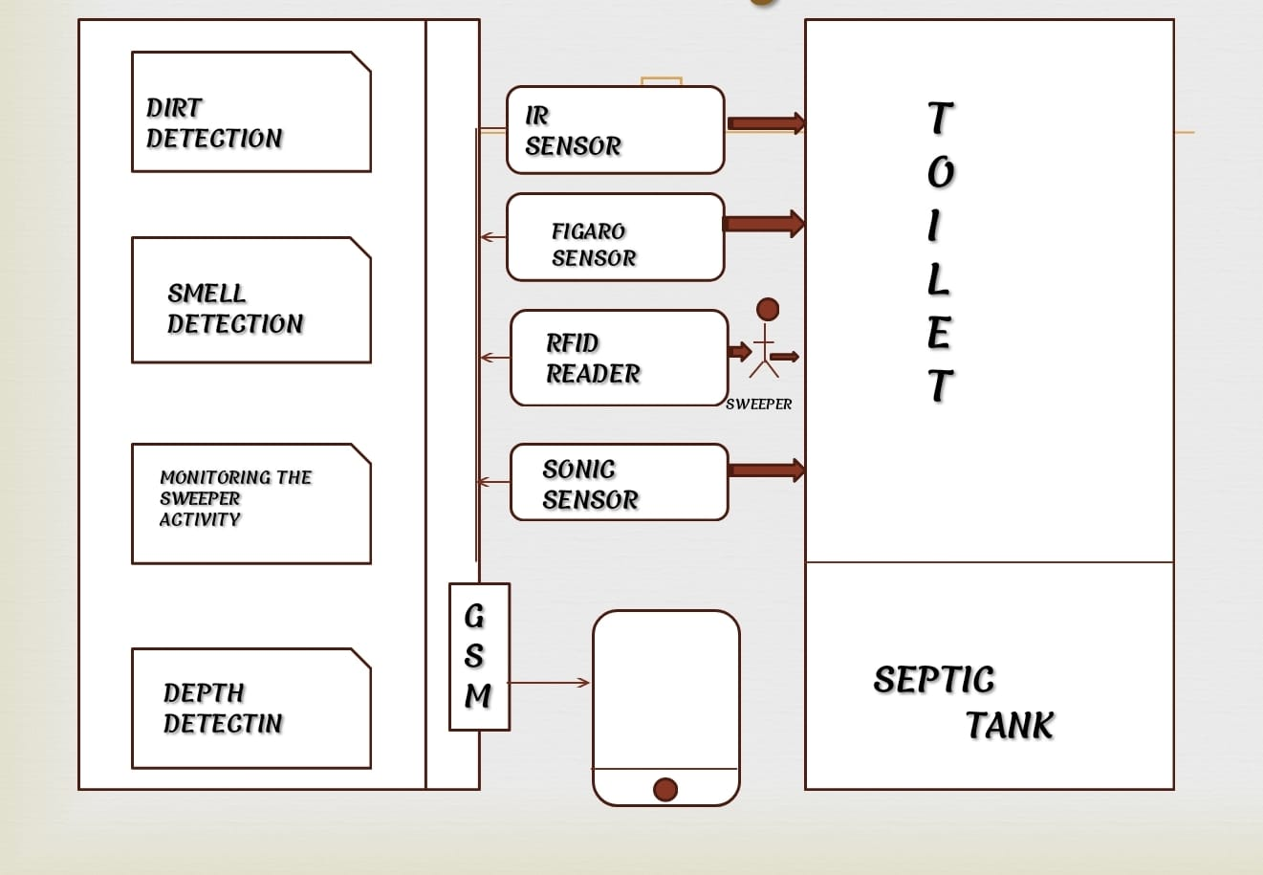

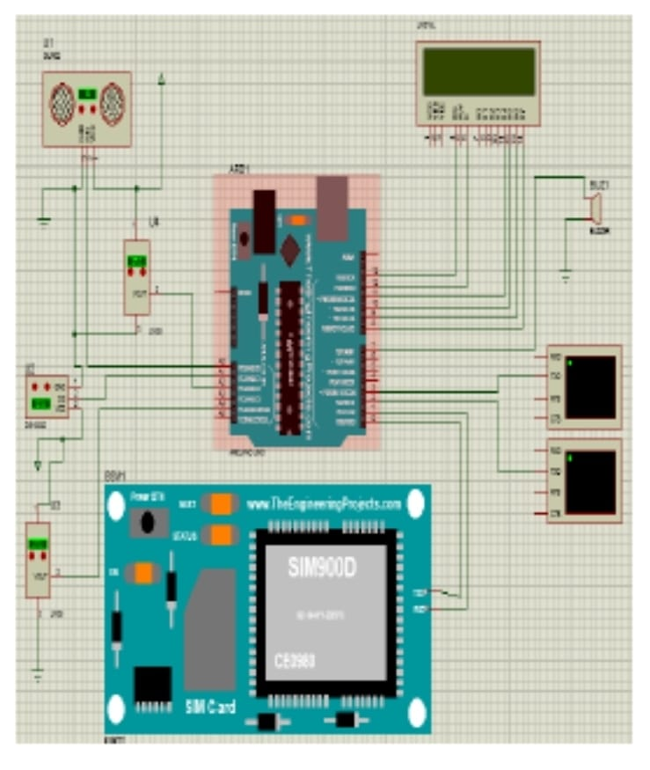CIRCUIT DIAGRAM

**COMPONENTS**

**Automated Flush and Faucet: Sensor-based flushing toilets and touchless faucets help reduce the spread of germs and conserve water.**

**Smart Toilet Seats: These can include features like bidets, seat warmers, and air dryers.**

**Occupancy Sensors: To monitor restroom traffic and provide real-time data on restroom availability.**

**LED Indicators: For indicating stall occupancy or cleaness status.**

**Hand Sanitizer Dispensers: Touchless hand sanitizer dispensers for improved hygiene.**

**High-Speed Hand Dryers: Efficient and hygienic hand dryers can reduce the use of paper towels.**

**Odor Control Systems: Automated air fresheners or odor-neutralizing systems.**

CODING

# Simulated occupancy sensor (replace with real hardware sensor)

def occupancy_sensor():

return random.choice([True, False])

# Simulated data for fixtures (replace with actual sensor data)

fixtures = {

"toilet_paper": 100,

"soap_dispenser": 75,

"paper_towels": 50

}

# Function to check and display restroom status

def display_restroom_status():

occupancy = occupancy_sensor()

if occupancy:

print("Restroom is occupied.")

else:

print("Restroom is vacant.")

print("Fixtures Status:")

for item, quantity in fixtures.items():

print(f"{item}: {quantity} units")

# Main loop for monitoring and displaying restroom status

while True:

display_restroom_status()

time.sleep(5) # Adjust the interval as needed

OUTPUT

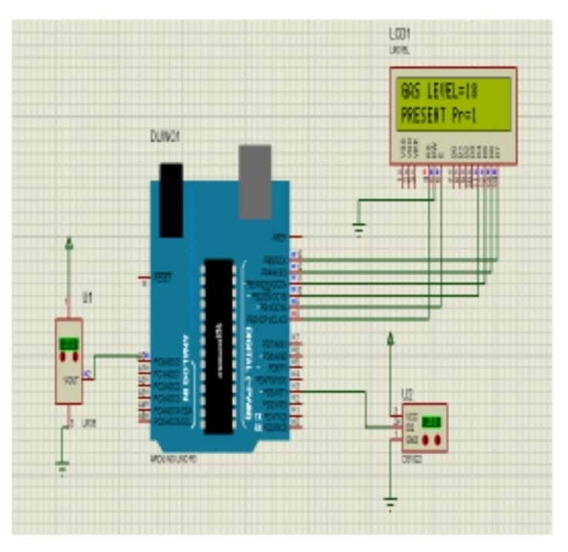

CONCLUSION

In conclusion, implementing smart public restrooms offers a range of benefits, including improved hygiene, resource efficiency, and enhanced user experience. These restrooms can utilize technology to monitor and maintain cleanliness, reduce water and energy consumption, and provide convenient features such as touchless fixtures and real-time occupancy data. While the initial investment may be higher, the long-term advantages in terms of public health, sustainability, and user satisfaction make smart public restrooms a worthwhile and forward-thinking solution for modern urban environments.